E.G.S.PILLAY ENGINEERING COLLEGE, NAGAPATTINAM
DEPARTMENT OF EEE
Model Exam
EE2351&POWER SYSTEM ANALYSIS
Class/Sem : III/VI Date : 6/4/15
Staff Name:AARTHI.B Duration: 3 hrs
Max. Mark:100
PART-A
Answer all the questions(10X2=20)
- What are the function of modern power system(co1)(understanding)
- Name the diagonal off diagonal element of y bus matrix(co2)(remembering)
- Why do we use ybus in load flow studies rather than zbus(co3)(understanding)
- When will generator bus treated as load bus(co3)(analyzing)
- What is the order of severity and occurrence of faults.(co4)(co5)(understanding)
- What are the characteristics of shunt and series fault(co4)(understanding)
- What are the observation from the analysis of various fault(co4)(co5)(understanding)
- Write a boundry condition for single line to ground fault(co4)(co5)(understanding)
- Different between voltage stability,rotor angle stability(co6) (analyzing)
- What is swing curve usage of swing curve(co6)(understanding)

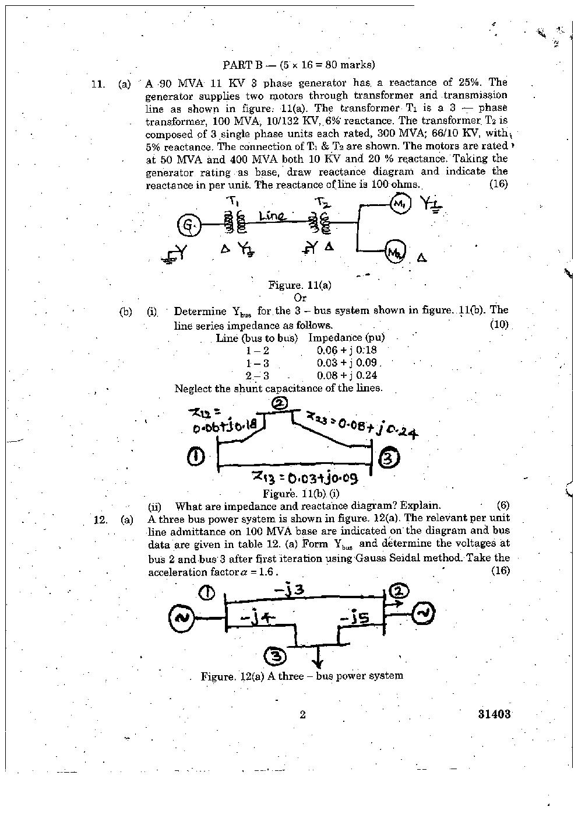

Co2 analyze
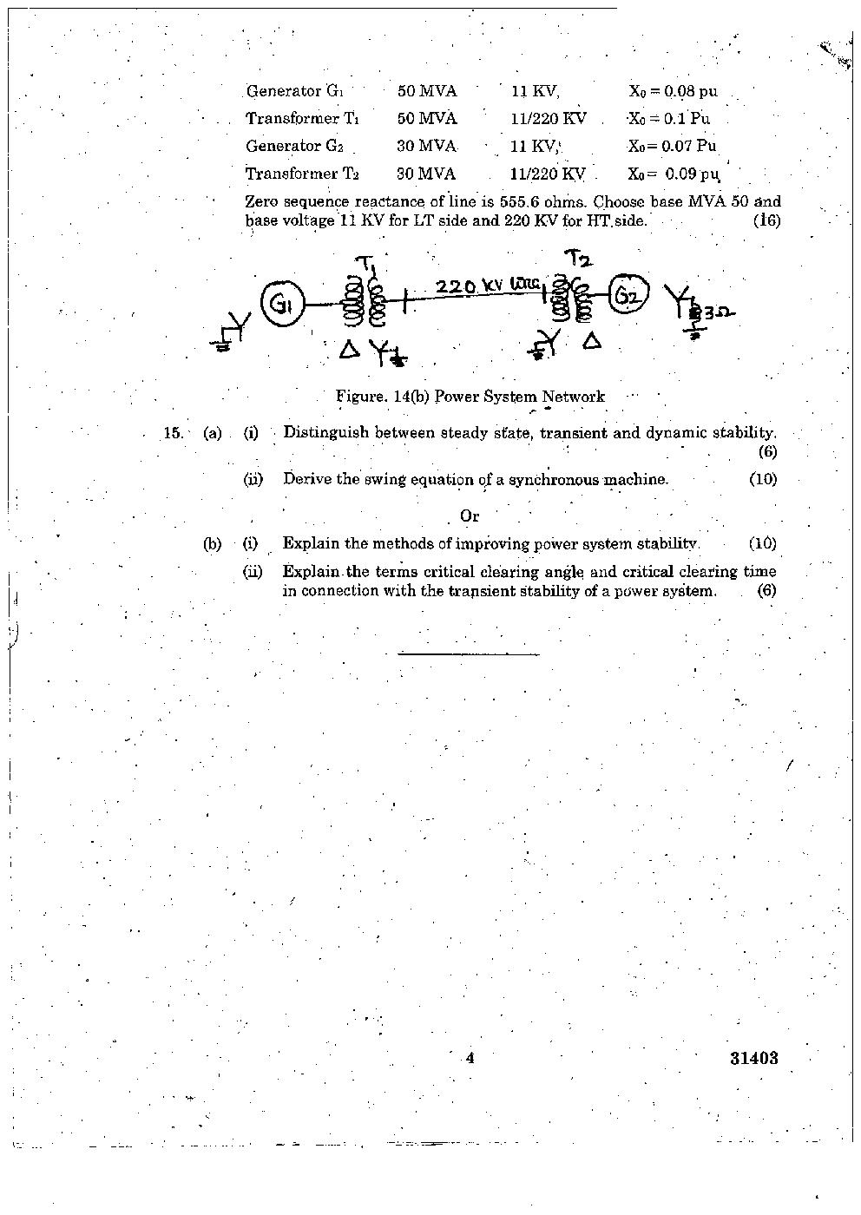
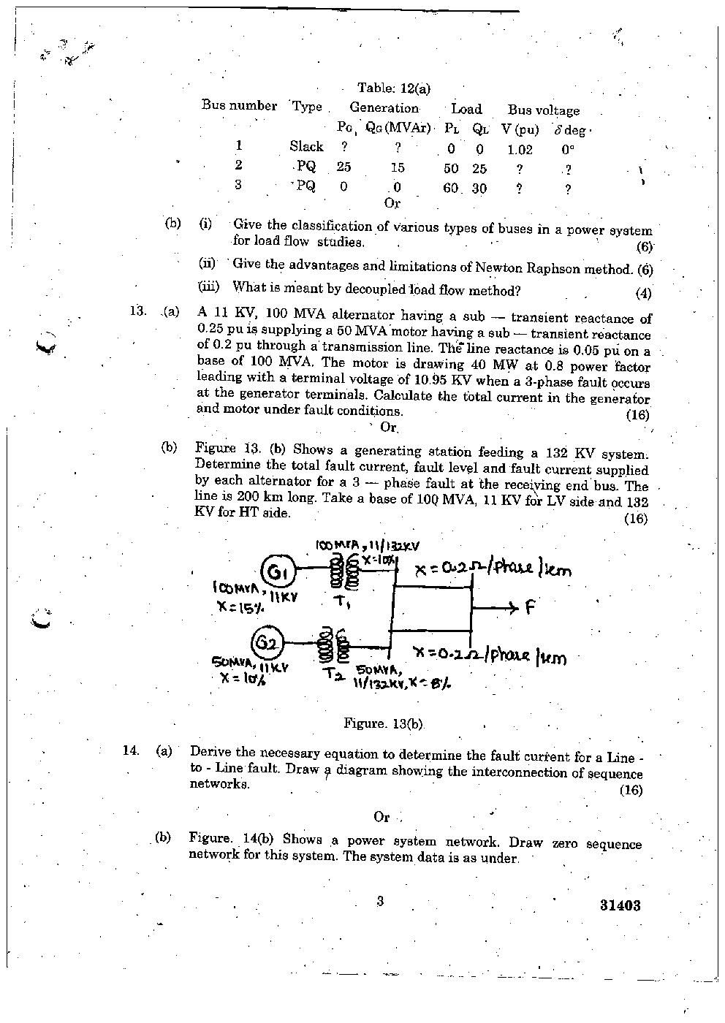
Co3 analyze
Co2 analyze
Co6 applying
Co5 applying
Co6 analyze
Co5 applying
Co4 applying
Co4 applying
Co3 undersandting

